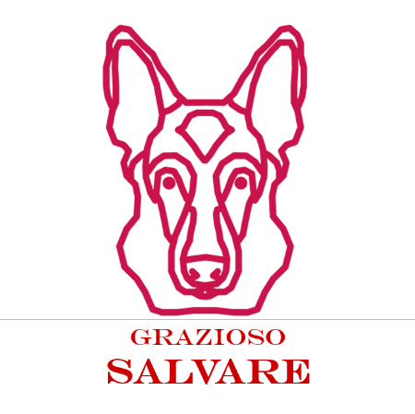Justin Perez  
Judy Mason

7-2

10/13/2025

Read Me

* Introduction
  + The Grazioso Salvare Dashboard is a web-based application for organizing and identifying the categorized dogs to see which are capable of certain types of rescue missions. The dashboard connects to MongoDB to bring a steam lined view & interact with the database.

* Key Features
  + Radio Button
    - Radio buttons for filter dogs by rescue type. These types being:
      * Water Rescue
      * Mountain/Wilderness rescue
      * Disaster/tracking rescue
      * Reset (To show dogs)
  + Pie chart
    - A pie chart to show breed distribution for displayed dogs
  + Map
    - A map to locate the selected dog
  + User Friendly Design
    - A user-friendly design where it’s only a few buttons to navigate to any dog you want along to check the corresponding information
* Tools Used
  + Python
  + Dash
  + MongoDB
  + Codio
  + Jupyter Labs
* How to Run
  + Open ProjectTwoDashboard.ipynb inside Jupyter Labs
  + Make sure CRUD_Python_Module.py is in the same folder
  + Make sure MongoDB is running and has an aac database with “animals” database collection
    - You will need to load this using the terminal
    - Ensure you have proper qualifications
  + Run all cells in the notebook
  + Use the Buttons to filter the dogs and interact with the tables, pie chart, and maps
* Challenges
  + A challenge I constantly endured was the Jupyter books themselves. Jupyter books don’t allow you to resize the output which made it hard to view all the content.
* Notes
  + Data will take a second to load before being able to be seen in the charts.
  + Map will not show initially this is because the data loads slowly
  + Bugs
    - When selecting the Pie chart along with reset it will become glitched.
* Screenshots
* Logo
  + 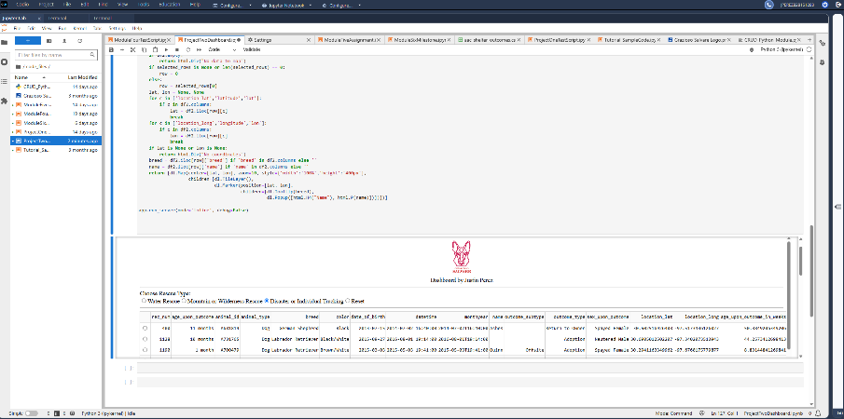
* Water Rescue Filter
  + 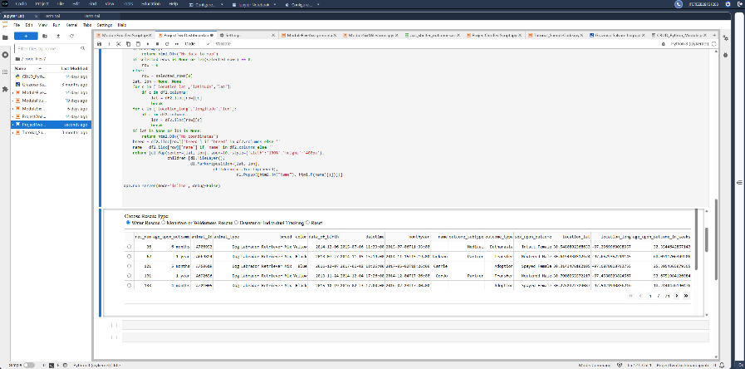
* Mountain / Wilderness Rescue Filter
  + 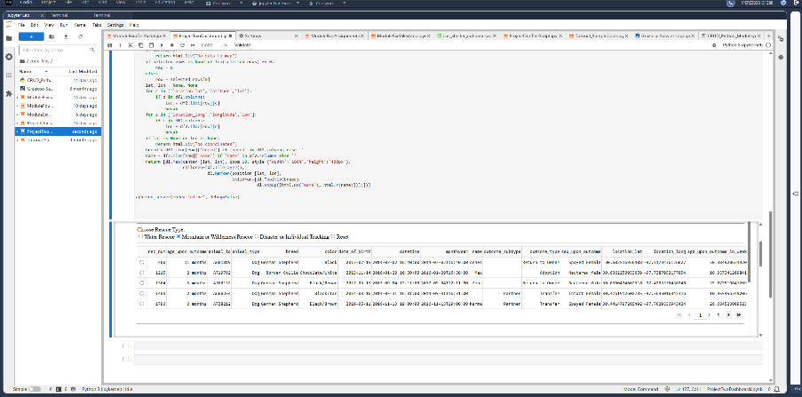
* Disaster / Tracking Rescue Filter
  + 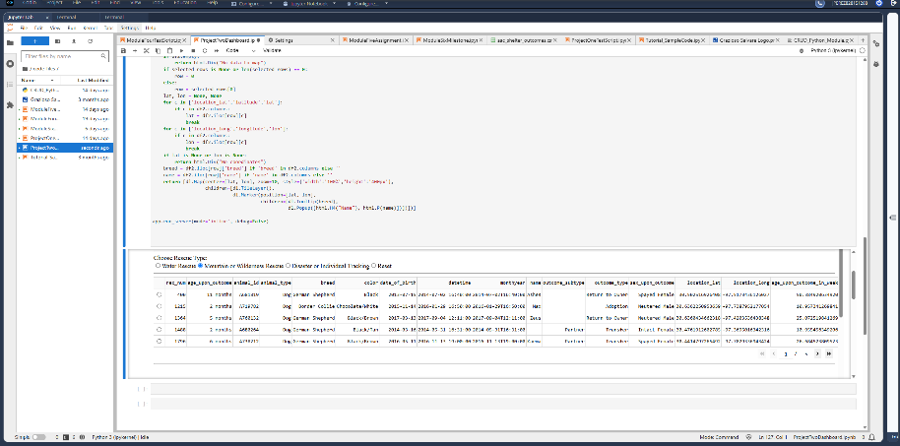
* Reset (All Dogs)
  + 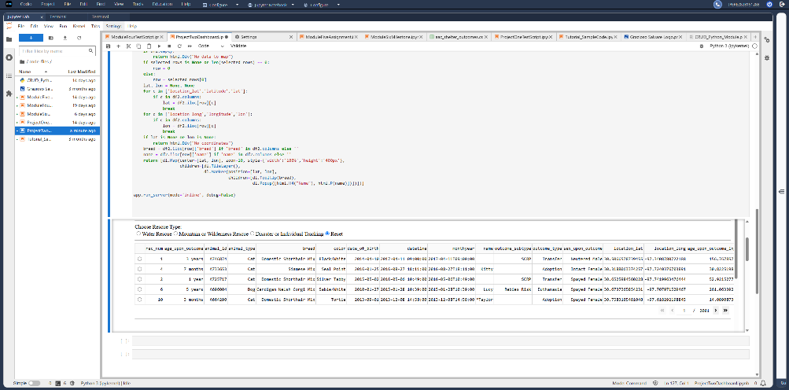
* Map
  + 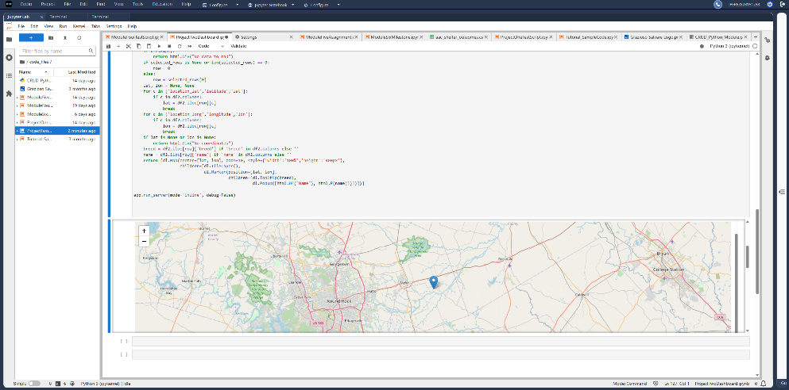
* Pie Chart
  + 